John-Joshua Izuegbu

Professor Zhang

CIS 3355

December 2nd, 2020

Hands-On Activity: Create and Consume a Web Service

* Using REST
* Create a REST API
* Consume a REST API
* Use PHPsu
* To start the MariaDBservice in your VM –start YaSTand select System – Services Manager
  + 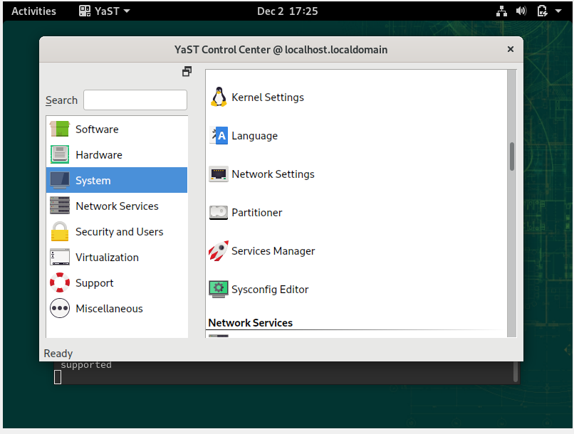
* Select the mariadb service •Change the Start Mode to On Boot •Start the service by clicking Start.Click Apply •Click Show Details •Click OK •Review the Summary of Changes and then click OK.
  + 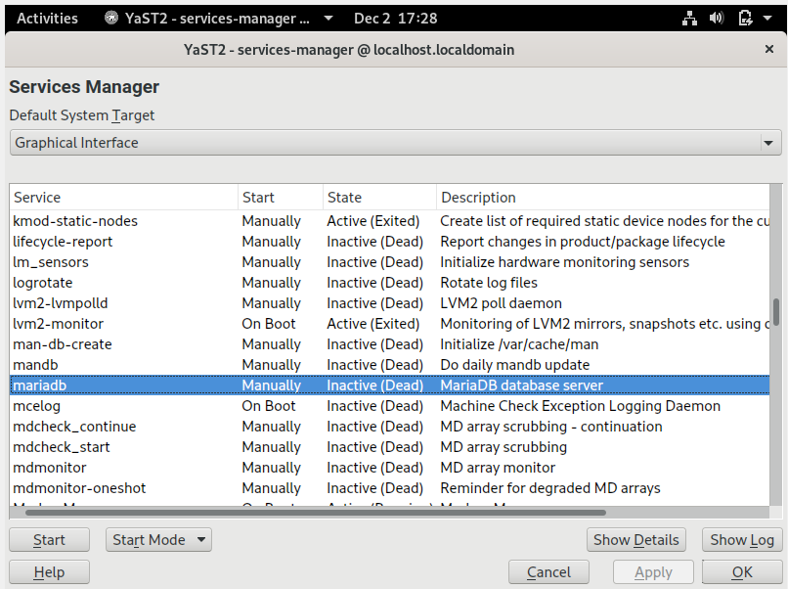
  + 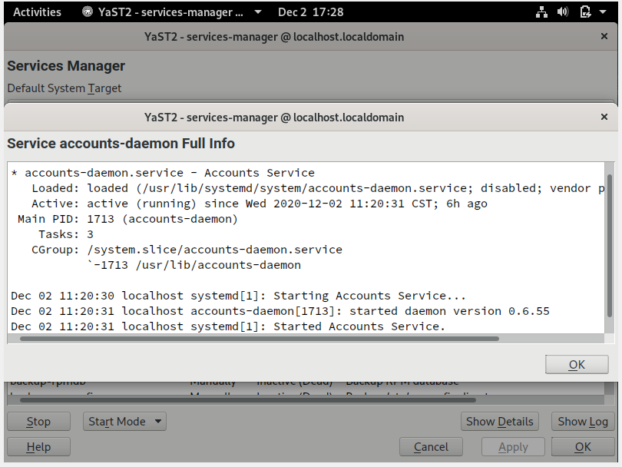
* In a terminal or console window where your privilege is elevated to rool, type mysql.
  + 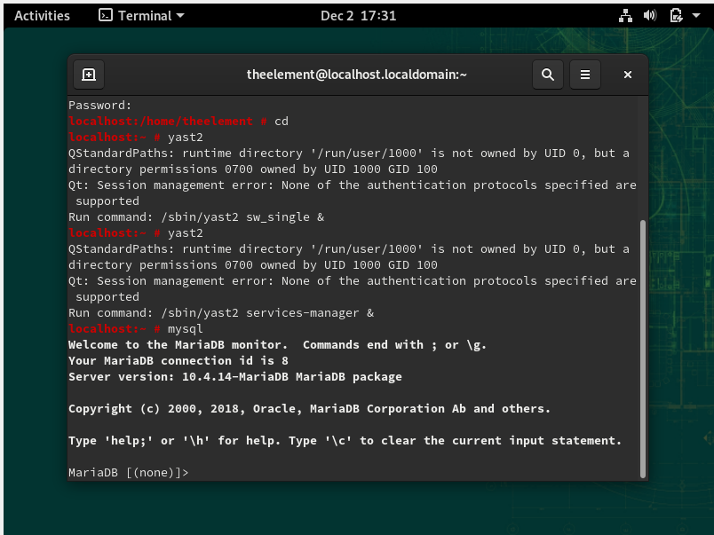
* At the database prompt in your terminal window type each of the three SQL commands shown here that do the following:
  + - •Create a database - name your database ws_rest_yourname •Tell the RDBMS which database to use •Create a table for storing information about transactions
  + 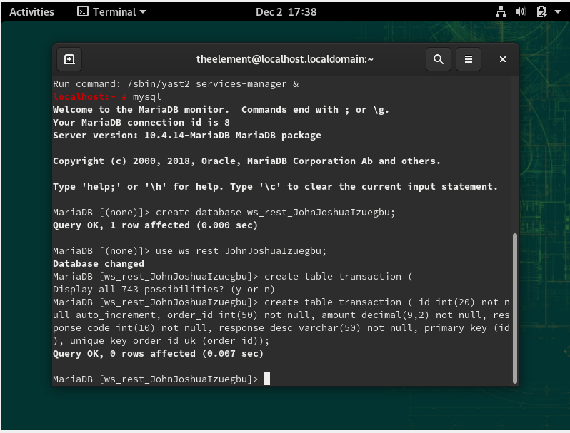
* Write additional similar commands to add 7 more rows of data (make it up, so yours uniquely belongs to you)•Type a SQL command to select all the data, confirming that the data is stored in the table•Type exit at the MariaDB prompt exit MySQL and return to the command line.
  + 